Social Sport Ladder
User Guide
Player Calendar Page

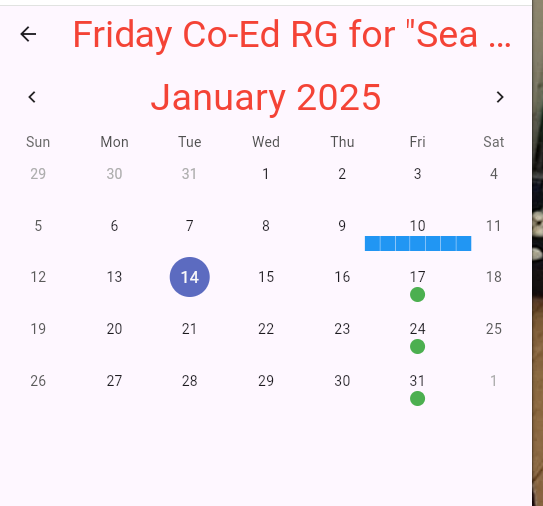

If you click on one of the green circles you can mark yourself as away for that day:
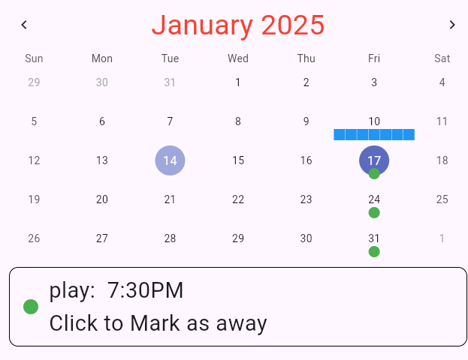
if you click on the Box with “Click to Mark as away” in it then it will change to:
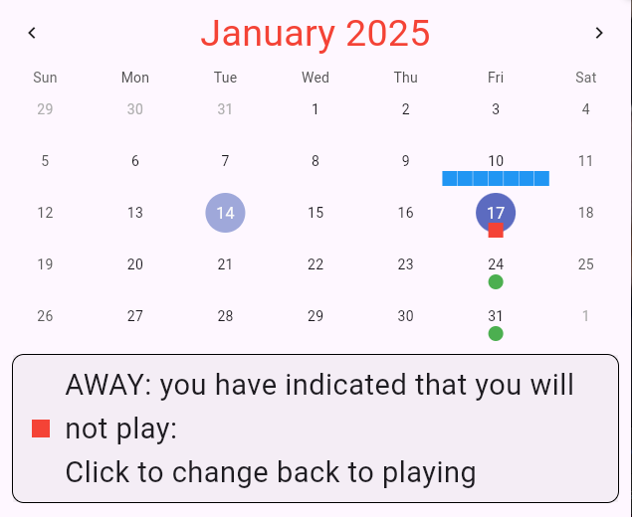
and you can, of course click on this again to switch it back to playing.

Note that there are rules that prevent you from marking yourself away or present too close to the scheduled start of play. The administrator has configured a time of day at which time you can no longer mark yourself as away.

Clicking on a previous play date will allow you to preview the scores on each of the courts:
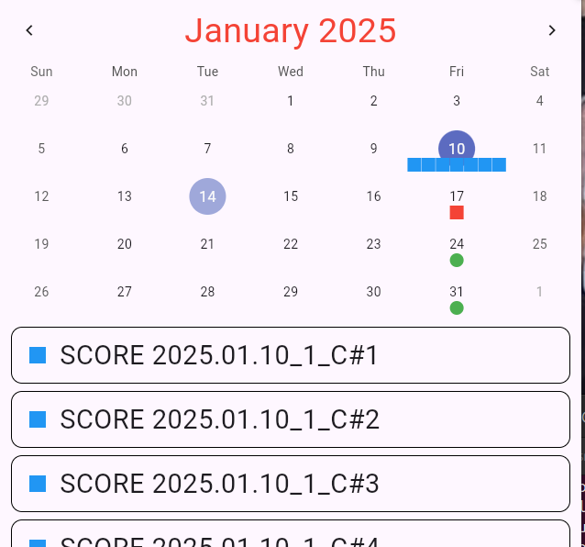
Clicking on one of these boxes will show you the recorded score for that court.

